**Name:** Chiko Mutandwa

**StudentNo:** ZGNZZT129

**Module** **Code:** ITEC301

**Module** **Name:** Internet Programming and E-Commerce

**Lecture:** Ndai Makurane

**Submission** **Day:** 27/05/2020 – 29/05/2020

Table of Contents

Question 1 2

1.1) 2

1.2) 3

1.3) 3

1.4) 3

1.5) 5

Question 2 6

2.1) 6

2.2) 7

2.3) 8

2.4) 10

Question 3 11

3.1) 11

3.2) 12

References 12

# Question 1

## 

**Innovation Phase**

This is the first phase and it took place from 1961 all the way up to 1974 in the evolution of the internet and is said to be the major, essential and the foundation of the Internet. This innovation phase consisted of the making of protocols such as the TCP/IP, client or server computing and the internet packet switching which were analysed and then afterwards they were put into practice in real equipment and software (Laudon & Traver, 2018). The internet all started with some research of how one can be able to send data or information proficiently over networks so that the information or data reaches its place of destination, without being lost, crumbled, or attenuated. When put into practice it only allowed individuals to communicate to other individuals at a time hence making it a one to one communication (Linda & William , 2015). This conceivable through the means of private networks or telephone systems that belonged to larger computer manufactures.

**Institutionalization Phase**

This is the second phase in the evolution of the internet this phase run from 1975 all the way to 1995. After the projects few successes large organizations like the United States of America (USA) NSF (National Science Foundation) and the DoD (Department of Defense) began to put funds in this project and provide rightfulness for the developing Internet (Laudon & Traver, 2018). During 1986, the National Science Foundation (NSF) began to take to accountability for the advancement of personal internet which at that point was know as NSFNET. When the concepts of the internet had been demonstrated or implemented quiet a few numbers of government began to support and they also supported demonstration projects. The Department of Defense donated $2million to additionally form them into a powerful military communications system. This extortion made what was then know as Advanced Research Projects Agency Network (ARPNET) that later on became known as the internet. As development kept on going, they were able to go from one page to another this was called hyperlink. They also made it easy for civilians by inventing the domain server in the late 80s which was able to turn IP addresses into words that were easy to understand (Blommaert, et al., 2016).

**Commercialization Phase**

This is the final and yet recent phase staring from the late 90s till the present, this is were private networks urged to dominate and extend the internet backbone just as local service past army bases and campuses to the reminder of the populace around the globe. In this phase we have seen a lot of things being invented but the standout was the emerging of e-commerce which began in the late 90s providing an online platform for retail store and many more (Laudon & Traver, 2018).

## 1.2)

Hypertext Markup Language 5 (HTML) is basically a web-based language that is used for both presenting and structuring word wide web (www) contents. This markup language is an exertion that carries request to the web by sorting out normal works, having that nuzzle of implementations from different browsers (Robbins, 2018). HTML5 is essentially an umbrella term for the up and coming generation of web applications and how they the functionality will grow with better versions of HTML, CSS, and better intuitiveness with JavaScript.

The latest version right now is of HTML is HTML5 which come with amazing features such as drag and drop and video playback features whereby back in the day additional plugins where to be installed to do such functionality (Laudon & Traver, 2018). HTML5 is additionally utilized in both mobile websites and mobile applications and is a significant apparatus tool in both versatile in web delivery and responsive websites. This markup language has become the catch all meaning that it includes the vide component as well as the utilization of the most current forms of CSS, JavaScript and others. HTML5 not only provides device independence yet can likewise get to the implicit functionality of the mobile phone, such as GPS. The making of web based mobile applications that can reproduce just like the way it is on the mobile application

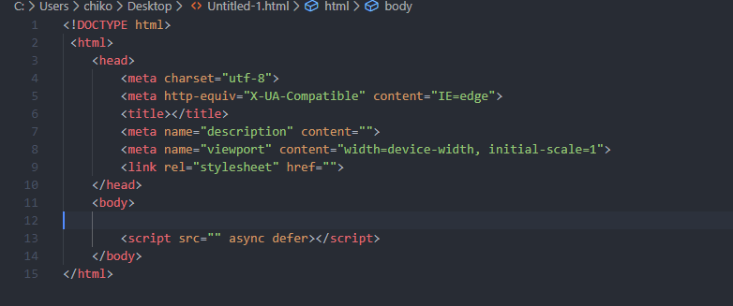

## 1.3)

* Chrome
* Mozilla Firefox
* Microsoft Edge
* Google
* Internet Explore

# Question 2

## 

## 2.1)

The TCP/IP (Transmission Control Protocol / Internet Protocol) is a protocol that discloses on how information ought to be addressed too, transferred, coded, decoded and even stored by the devices from start to finish of the devices communicating together. This protocol is the fundamental protocol of the IP suit, because it is safe, no errors and lastly it can be reliable of exchanging or transferring information between applications running through an internet media (Kumar & Subramanian, 2015). If we breakdown TCP/IP the Transmission Control Protocol (TCP) deals with setting up connections between both the receiving computer and the sending computer, and then ensures that packages that are sent by one PC are gotten in a similar arrangement, without any packages lost. Internet Protocol (IP) deals with giving addresses and also make sure that packets arrive safely. TCP/IP is broken down into four separate layers, with each layer taking care of a specific part of the packet as it goes or comes from a computer.

**Network Interface Layer**

This layer is liable for putting packets on and getting them from the network medium for instance through ethernet.

**Internet Layer**

This layer on the other hand deals with addressing, directing messages on the internet and packaging packets.

**Transport Layer**

This layer is responsible for giving different protocols inside the TCP/IP protocol suite to communicate with each other by recognizing and sequencing the packages from and to applications (Eltaeib, 2017).

**Application Layer**

The application layer deals with incorporating different types of protocols that are used to help trade information and make user services available

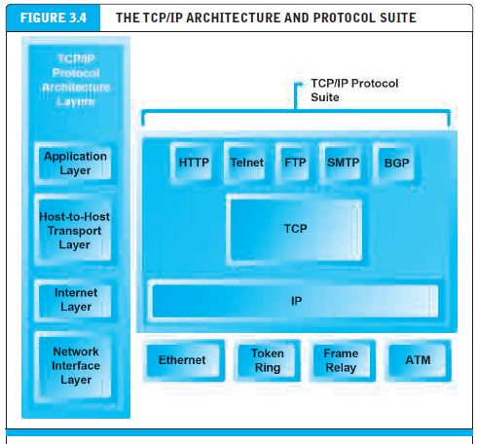

Figure 1 shows the TCP/IP Architecture (Laudon & Traver, 2018)

## 2.2)

Top-Level Domain (TLD) alludes to the last portion of a given domain name and they also reside in the root server. They are different types of top-level domains namely: -

.com

These are the most common top-level domains and the are also know as commercial. This top-level domain was the first to be used. While .com was at first made for use by business organizations, limitations on this were not as tough (Eltaeib, 2017). This top-level domain is the most well known and regularly utilized for websites, email, and businesses.

.net

This one just by the name .net which is short for network, this top-level domain was made explicitly for institutes that participated in network technologies such as ISP (Internet Service Provider) (Lam, 2019). This top-level domain is also known as organize most organizations who are into network technologies, .net is starting to become popular just like the .com.

.edu

This domain is known for training it was made for educational purposes. Despite the fact that this .edu was created for universities and colleges the .edu became related to only for educational purposes.

.org

Is know for organizations .org was mainly made for non profitable organizations, but nowadays we see it being used in educational institutes organizations and business.

.mil

This top-level domain was created explicitly for the military. This top-level domain is not like the other types of domains, where anyone can use for this one no one apart from the military is allowed to have this domain (Rajasekera, 2014).

.gov

This top-level domain is very similar and is also very strict like the .mil top level domain whereby only employees that work in the government can access this top-level domain (Paltridge & Matsui, 2015).

Countries with their domains

.uk (United Kingdom)

.ca (Canada)

.zm (Zambia)

.us (United States of America)

.za (South Afica)

# References

Blommaert, L., Coenders, M. & Tubergen, F. v., 2016. Discrimination of Arabic-Named Applicants in the Netherlands: An Internet-Based Field Experiment Examining Different Phases in Online Recruitment. Issue 10, pp. 1-26.

Chaffey, D., 2015. *Digital Business and E-Commerce Management.* 6th ed. United Kingdom: Person (Intl).

Comer , D. E., 2019. *THE INTERNET BOOK.* 5th ed. s.l.:Taylor & Francis Group.

Comer, D. E., 2018. *The Internet Book: Everything You Need to Know about Computer Networking and how the Internet Works.* 3 ed. United Staes of America: Prentice-Hall, Inc.

Conrad, D., 2017. The Domain Server. pp. 1-10.

Eltaeib, T., 2017. TCP/IP PROTOCOL LAYERING. 1(2), pp. 1-67.

Jain, R., 2016. Computer Networking and Internet Protocols A Comprehensive Introduction. pp. 1-263.

Kumar, D. M. A. & Subramanian, K., 2015. A New Security Architecture for TCP/IP Protocol Suite. 1(3), pp. 177-181.

Lam, E., 2019. TCP/IP Fundamentals. Volume 3, pp. 35-83.

Laudon, K. C. & Traver, C. G., 2018. *E-Commerce.* 13th ed. New York: Pearson Education, Inc.

Linda , D. & William , H. B., 2015. Pursuing the Course from Research to Practice. Volume 5, pp. 55-59.

Meyers, M., 2017. *CompTIA A+ Certification All-in-One Exam Guide.* 9th ed. Houston: McGraw Hill Professional.

Paltridge, D. S. & Matsui, M., 2015. Generic Top Level Domain Names. 8(1), pp. 1-5.

Rajasekera, J., 2014. Potetial Impact of Top Level Domain Name Liberalization on ccTLD. Volume 6, pp. 1-355.

Robbins, . J., 2018. *Learning Web Design: A Beginner's Guide to HTML, CSS, JavaScript, and Web Graphics.* 5th ed. United States of America: s.n.